**CODES RELATED**

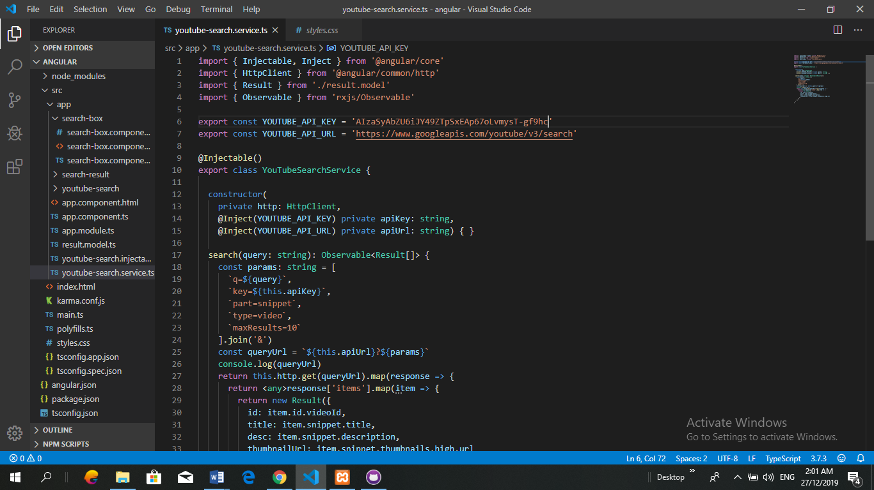

**Figure 1:** YouTube API key implemented

This codes for YouTube API for fetch data from YouTube and comes out with the result. This token generated by google console.

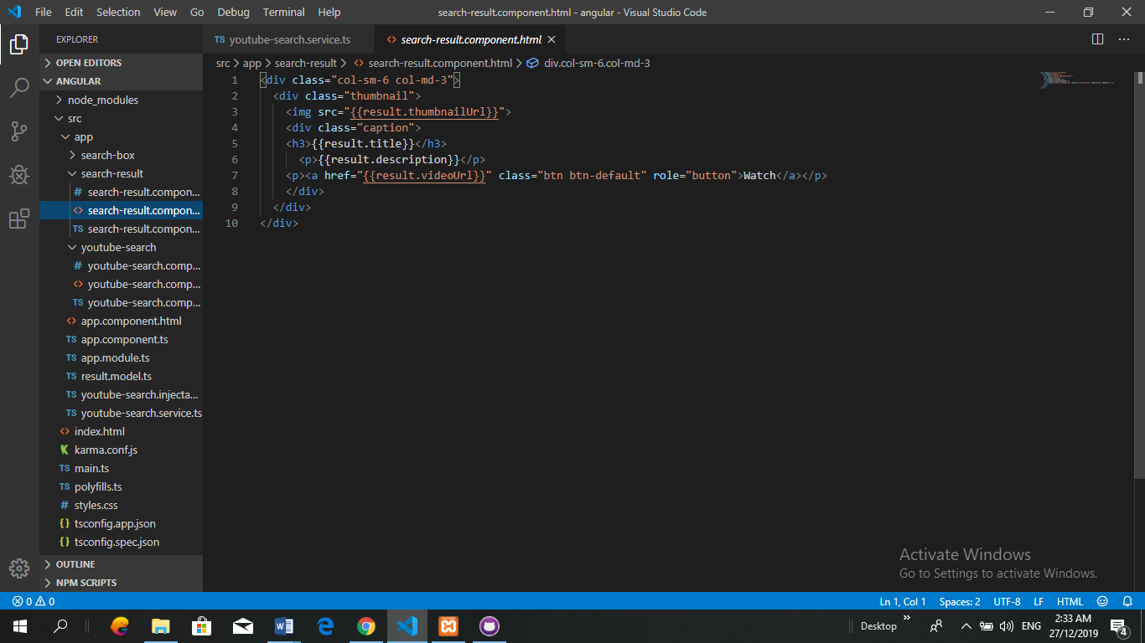

**Figure 2:** Code of Search Result

This codes for user to search result.

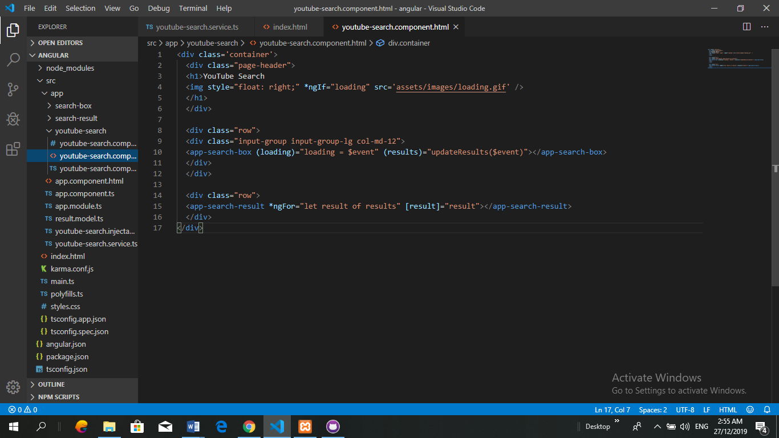

**Figure 3:** Code of Search Component

This for search component of the youtube.

**EXPLANATION FOR API**

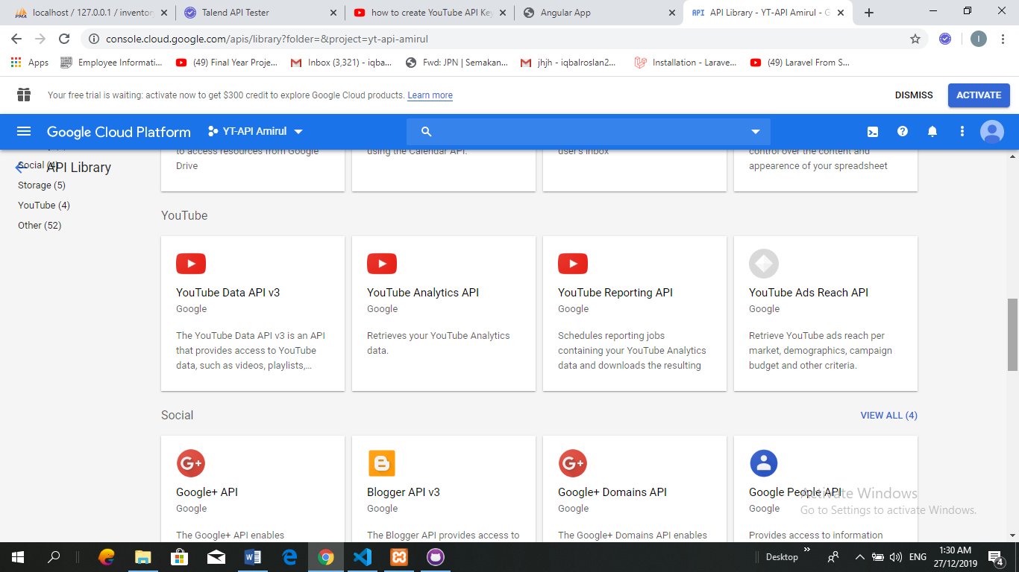

**Figure 4:** YouTube API version 3

This step for to get YouTube API from google cloud console. Developer need to choose YouTube API v3 that provides access to YouTube data such as videos, playlist and others.

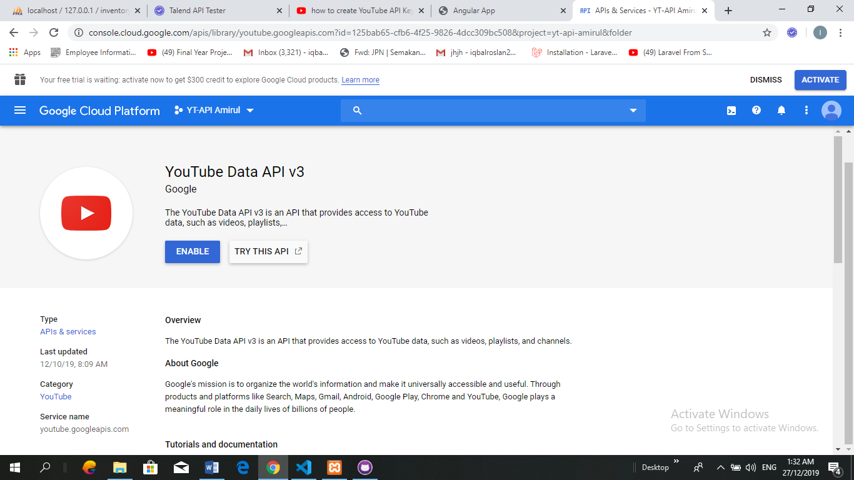

**Figure 5:** Enable YouTube API

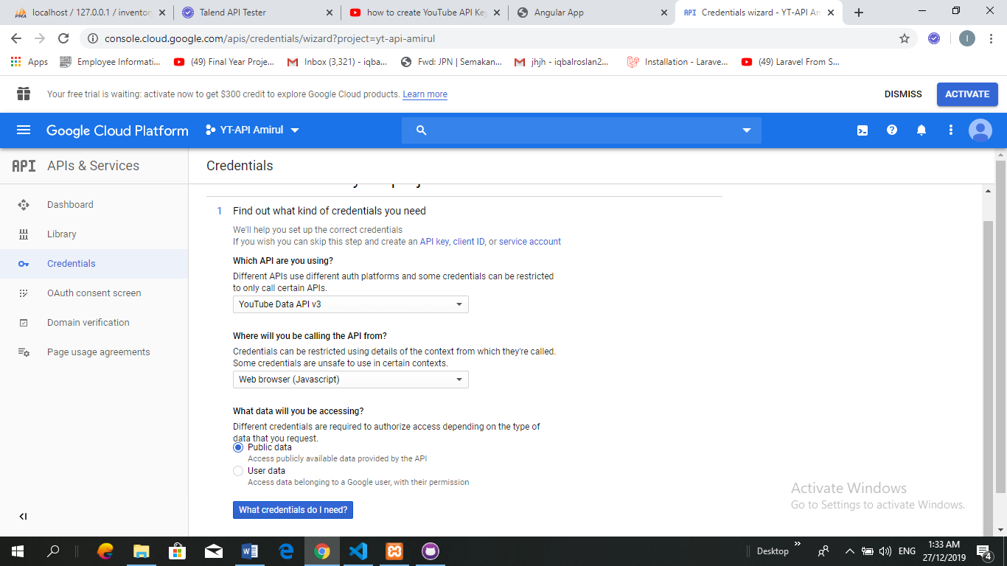

**Figure 6:** Create credentials setup YouTube API and set to public to access

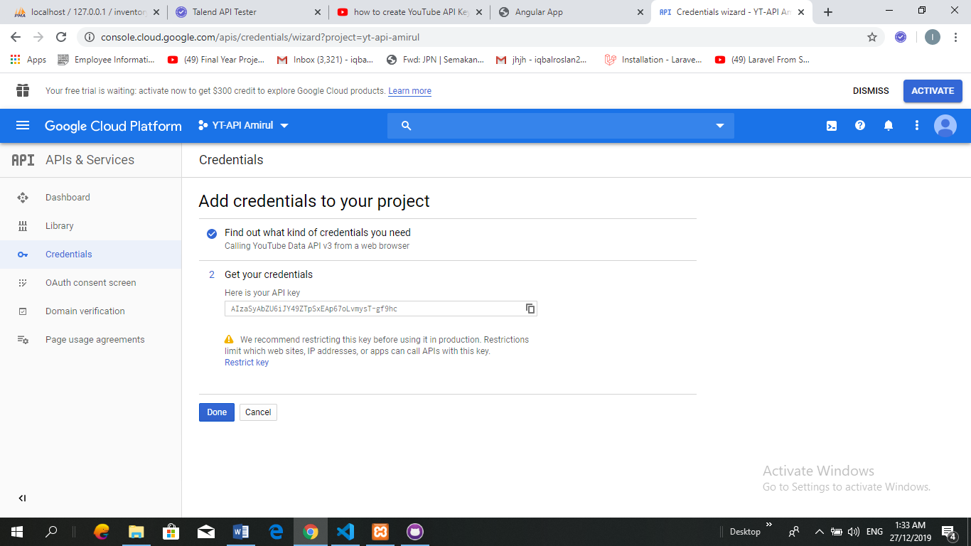

**Figure 7:** The credentials API key have been successfully generated and ready to use

**RESPONSE RESULT**

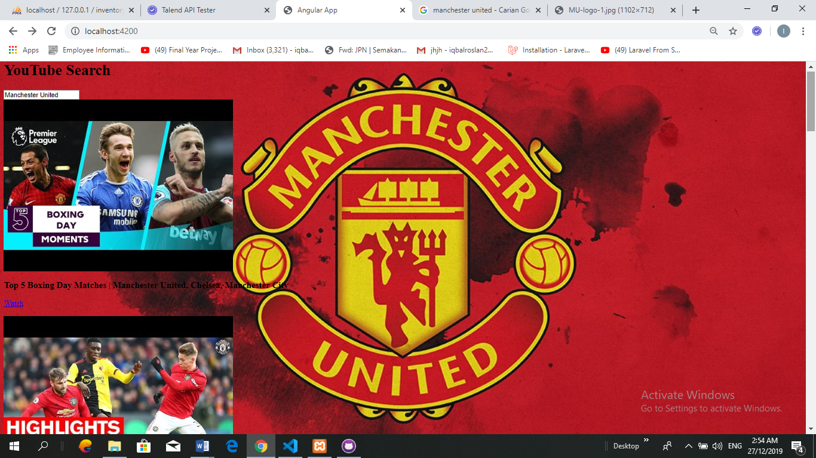

**Figure 8:** Response Result

Address GitHub:

<https://github.com/AmirulAsyraf96/YouTube-API>